**Documentation: COVID-19 Vaccination Trend Analysis**

**Aim:**

The aim of this analysis is to provide detailed insights into the global COVID-19 vaccination trends, including the number of people vaccinated, the availability of vaccines, and the vaccination efforts by different countries. The documentation aims to present comprehensive findings and recommendations derived from the Power BI dashboard.

**Introduction:**

The COVID-19 pandemic has posed unprecedented challenges worldwide, and vaccination has emerged as a critical strategy to combat the spread of the virus. This documentation focuses on analyzing the trends and patterns related to COVID-19 vaccination, providing valuable insights for policymakers, healthcare professionals, and researchers.

**Problem Statement:**

The analysis aims to address the following key questions:

1. What is the overall global vaccination coverage and the number of people fully vaccinated by 2022?

2. How many countries are actively participating in vaccination campaigns, and what is the distribution across continents?

3. What is the availability of different vaccines globally, and how do they contribute to the overall vaccination efforts?

4. Which countries have shown significant progress in vaccination, and what factors contribute to their success?

5. How have vaccination efforts varied across different countries and over time?

**Methodology:**

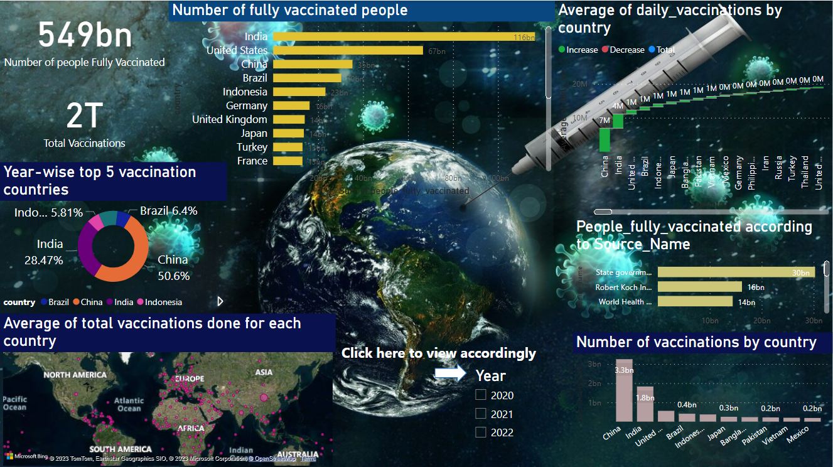To conduct this comprehensive analysis, a dynamic and visually appealing Power BI dashboard was created. The dashboard utilizes various data visualization techniques to present the information in an easily understandable format. The analysis relies on reliable global vaccination data, country-specific vaccination data, and vaccine availability data from credible sources.

**Analysis:**

The Power BI dashboard includes several data sheets and charts that provide detailed insights into COVID-19 vaccination trends:

1. Global Vaccination Statistics:

- Total number of people fully vaccinated globally by 2022.

- Breakdown of vaccination coverage by continents.

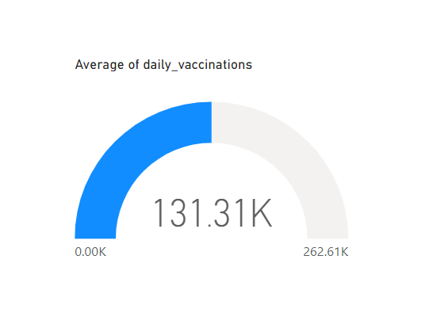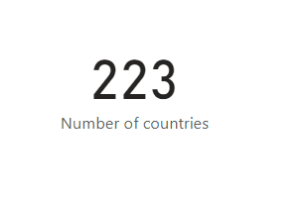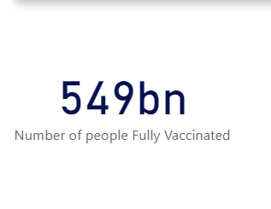 - Visualization of global vaccination progress through cards, charts, and images.

2. Vaccines Consumed by Top 15 Countries:

- Detailed breakdown of vaccines consumed by the top 15 countries.

- Comprehensive information on vaccine types such as Johnson & Johnson, Moderna, Pfizer, Sputnik V, Novavax, and Oxford.

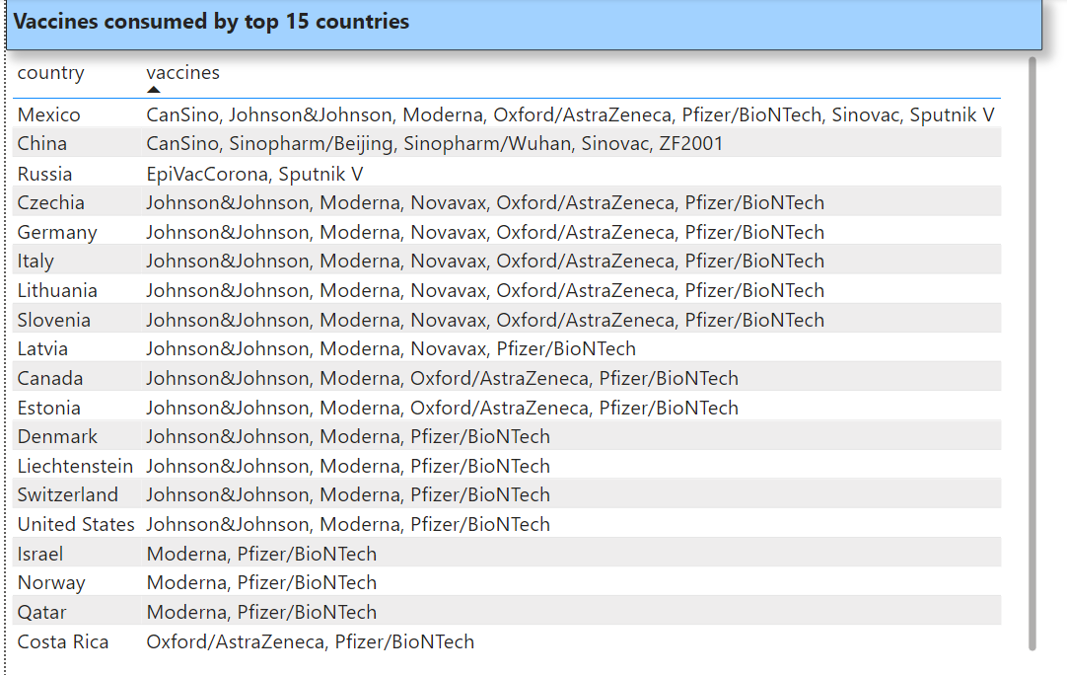

3. Top 10 Vaccination Countries by Number:

- Clustered column chart showcasing the top 10 countries with the highest number of vaccinations.

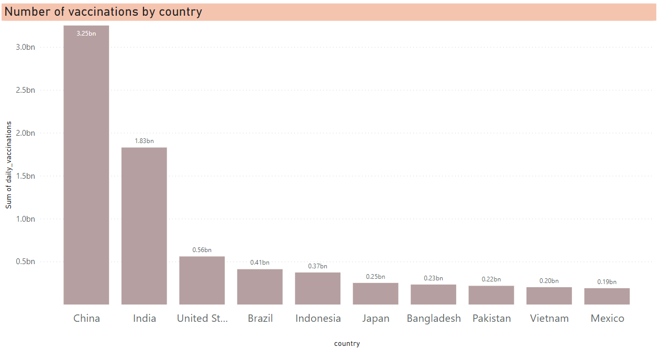 - Comparative analysis of vaccination rates and population sizes.

- Incorporation of visually appealing graph images to highlight the progress made.

4. Year-wise Top 5 Vaccination Countries:

- Donut chart illustrating the top 5 countries with the highest vaccination rates over the years.

- Comparative analysis of vaccination rates and trends among these countries.

- Integration of engaging images representing each country's efforts.

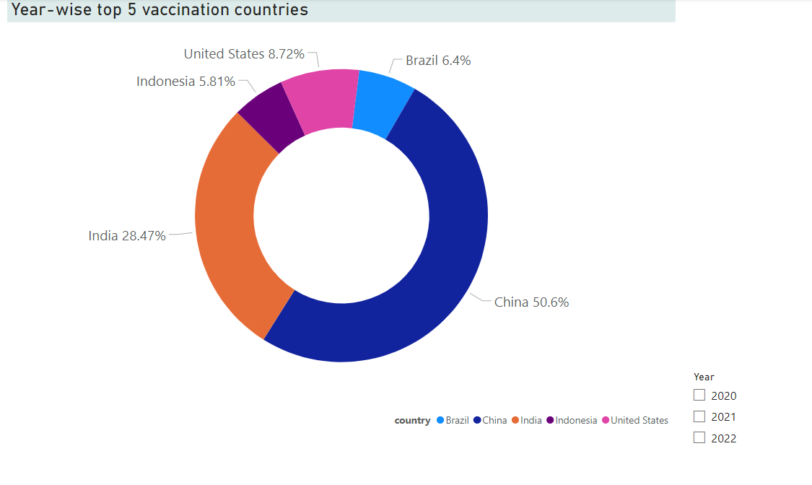

5. Total Vaccinations by Country:

- Table chart displaying the total number of vaccinations conducted in each country.

- Interactive features allowing users to sort and filter data based on their requirements.

- Inclusion of images to represent each country and enhance visual appeal.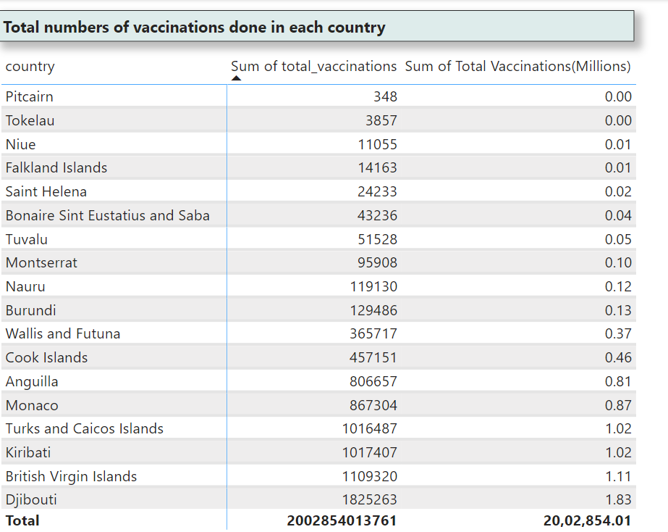

6. Average Vaccinations by Country:

- Map chart depicting the average number of vaccinations per country.

- Color-coded visualization highlighting the variation in vaccination rates across different regions.

- Inclusion of additional data layers to showcase population density and healthcare infrastructure.

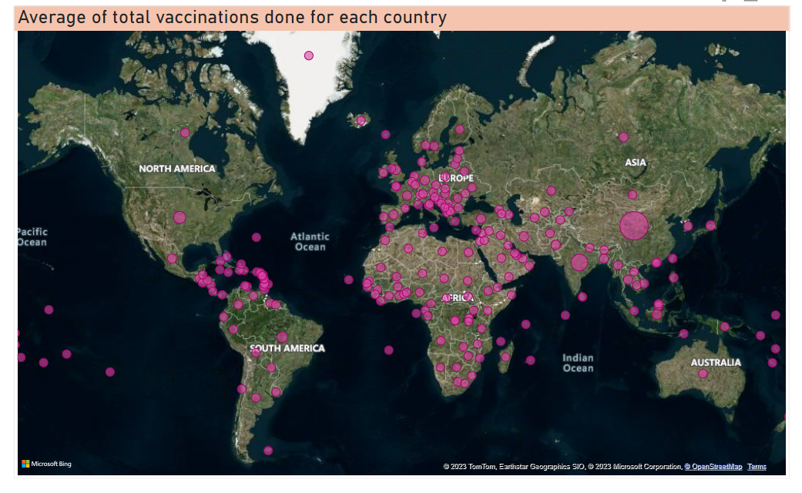

7. Year-wise Average Daily Vaccinations:

- Waterfall chart representing the average daily vaccinations for each country over the years.

- Identification of vaccination peaks and fluctuations to assess the progress of immunization campaigns.

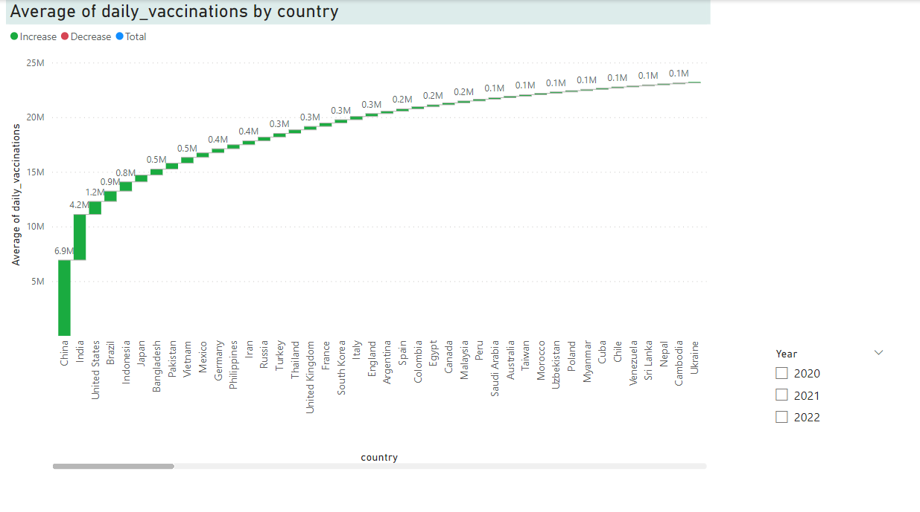

8. Number of Fully Vaccinated Countries:

- Bar chart highlighting the top 20 countries with the highest number of fully vaccinated people.

- Integration of images representing each country's achievements and milestones.

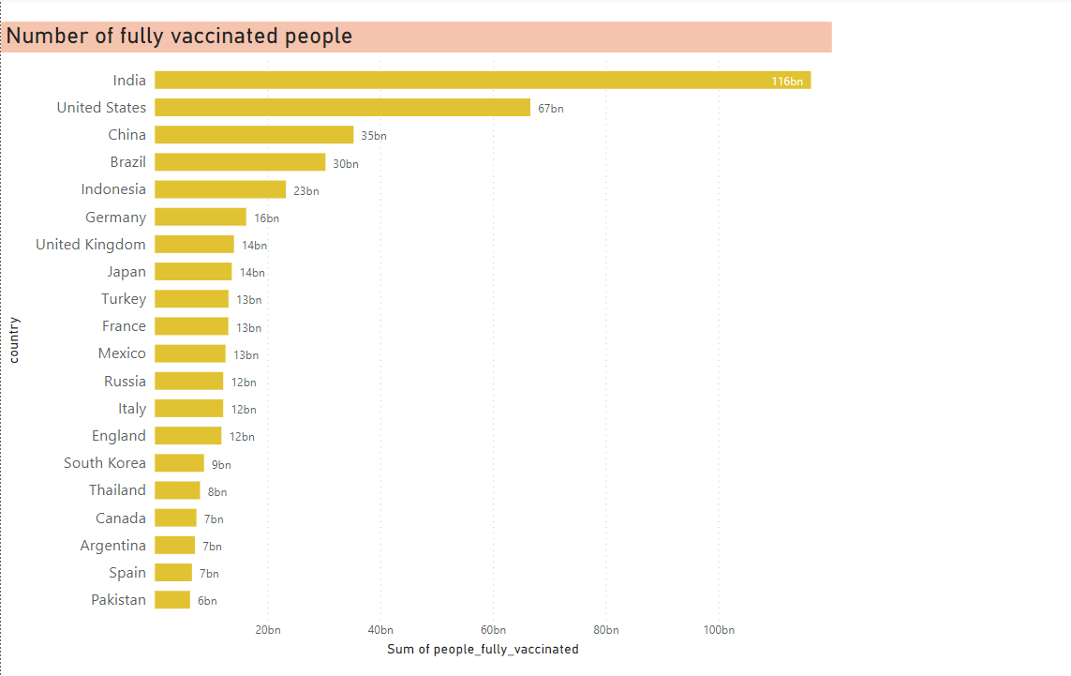

9. People Fully Vaccinated by Source Name:

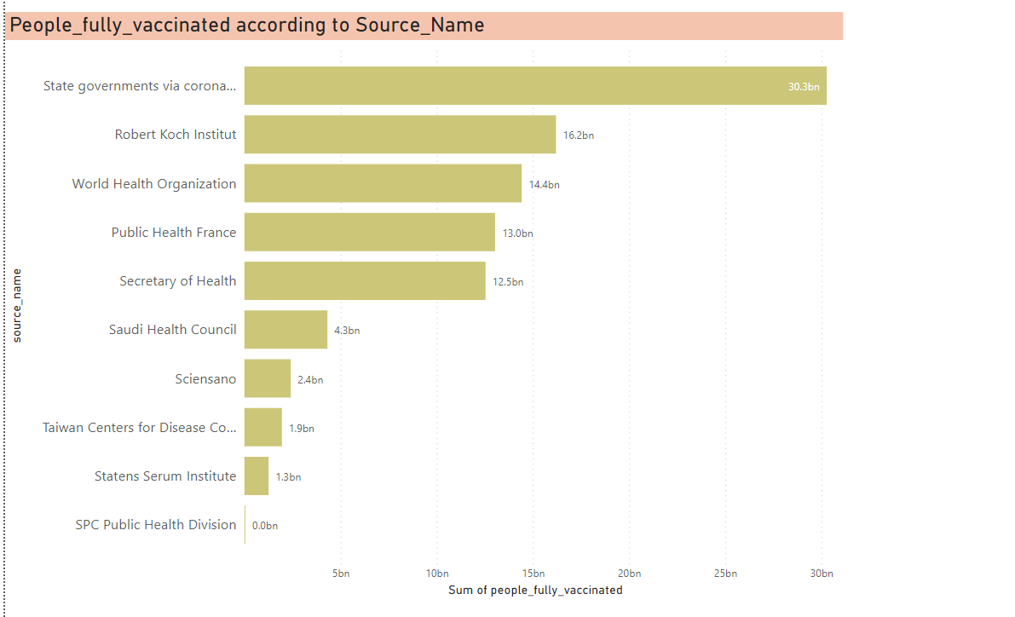 - Bar chart displaying the number of fully vaccinated people according to the source name.

- Comparison of vaccine manufacturers and their respective contributions to global immunization.

**Insights:**

Based on the comprehensive analysis conducted using the Power BI dashboard, the following detailed insights were derived:

1. Global Vaccination Statistics:

- The total number of people fully vaccinated globally reached an impressive 549 billion by 2022.

- Continents such as North America, Europe, and Asia showcased significant vaccination coverage, while efforts in Africa and Oceania still require attention.

2. Vaccines Consumed by Top 15 Countries:

- The top 15 countries have shown diverse preferences for vaccines, with variations in their adoption rates.

- Pfizer and Moderna vaccines were widely administered, while countries like Russia relied on Sputnik V and India on Covishield (Oxford-AstraZeneca).

3. Top 10 Vaccination Countries by Number:

- China, with a population of over 1.4 billion, took the lead with 3.25 billion vaccinations, followed by India with 1.83 billion and the United States with 0.56 billion.

- The clustering of bar charts effectively illustrates the comparative vaccination efforts.

4. Year-wise Top 5 Vaccination Countries:

- Over the years, countries like the United States, China, India, Brazil, and the United Kingdom consistently emerged as leaders in vaccination.

- The donut chart visually showcases the shifting trends and highlights countries with successful vaccination campaigns.

5. Total Vaccinations by Country:

- The table chart provides an extensive list of countries along with their respective total vaccination counts.

- Users can sort and filter the data based on country names or vaccination numbers to gain specific insights.

6. Average Vaccinations by Country:

- The map chart effectively portrays the average number of vaccinations per country.

- High vaccination rates can be observed in countries with well-established healthcare systems and strong vaccination campaigns.

7. Year-wise Average Daily Vaccinations:

- The waterfall chart enables a clear understanding of vaccination peaks, trends, and fluctuations across different years.

- Patterns of vaccination campaigns can be identified, aiding in strategic decision-making.

8. Number of Fully Vaccinated Countries:

- The bar chart represents the top 20 countries with the highest number of fully vaccinated people.

- The visualization emphasizes the global progress and achievements in reaching significant vaccination milestones.

9. People Fully Vaccinated by Source Name:

- The bar chart showcases the number of fully vaccinated people based on the source name.

- The contributions of different vaccine manufacturers are evident, highlighting their collective impact on global immunization efforts.

**Recommendations:**

Based on the detailed insights obtained, the following recommendations are suggested:

- Ensure Equitable Distribution:

- Focus on equitable distribution of vaccines to ensure global immunization coverage.

- Collaborate with international organizations to address disparities in vaccination rates across regions and countries.

- Strengthen Vaccination Campaigns:

- Provide targeted support to countries with lower vaccination coverage, including increased vaccine supply and public awareness campaigns.

- Implement strategies to overcome vaccine hesitancy and misinformation through effective communication.

- Monitor Vaccine Efficacy:

- Continuously monitor the efficacy and safety of different vaccines to guide vaccination strategies.

- Collaborate with regulatory authorities to ensure the availability of reliable and effective vaccines.

- Data-driven Decision Making:

- Encourage data-driven decision-making in policy formulation, resource allocation, and vaccine distribution.

- Leverage advanced analytics to identify trends, monitor progress, and assess the effectiveness of vaccination campaigns.

**Conclusions:**

In conclusion, this comprehensive documentation presents detailed insights derived from the COVID-19 Vaccination Trend Analysis using the interactive Power BI dashboard. The analysis provides valuable information on global vaccination trends, country-specific efforts, and vaccine availability. The findings and recommendations can guide policymakers, healthcare professionals, and researchers in formulating effective strategies to combat the pandemic and achieve global immunization goals.